CREATE TABLE EventRequest

(

EventNo VARCHAR2(8) CONSTRAINT EventNoNotNull NOT NULL,

DateHeld DATE CONSTRAINT DateHeldNameNotNull NOT NULL,

DateReq DATE CONSTRAINT DateReqNotNull NOT NULL,

CustNo VARCHAR2(8) CONSTRAINT Cust1NoNotNull NOT NULL,

FacNo VARCHAR2(8) CONSTRAINT Fac1NoNotNull NOT NULL,

DateAuth DATE,

Status VARCHAR2(20) CONSTRAINT StatuNotNull NOT NULL,

EstCost NUMBER(8,2) CONSTRAINT EstCostNotNull NOT NULL,

EstAudience NUMBER(10) CONSTRAINT EstAudNotNull NOT NULL,

BudNo VARCHAR2(8),

CONSTRAINT PK_EventRequest PRIMARY KEY (EventNo),

CONSTRAINT FK_FAC1N0 FOREIGN KEY (FacNo) REFERENCES FACILITY (FacNo),

CONSTRAINT FK_CUST1N0 FOREIGN KEY (CustNo) REFERENCES CUSTOMER (CustNo),

CONSTRAINT CHECK_ESTAUD CHECK (EstAudience > 0),

CONSTRAINT CHECK_STATUS CHECK (Status IN ('Approved', 'Pending', 'Denied'))

) ;

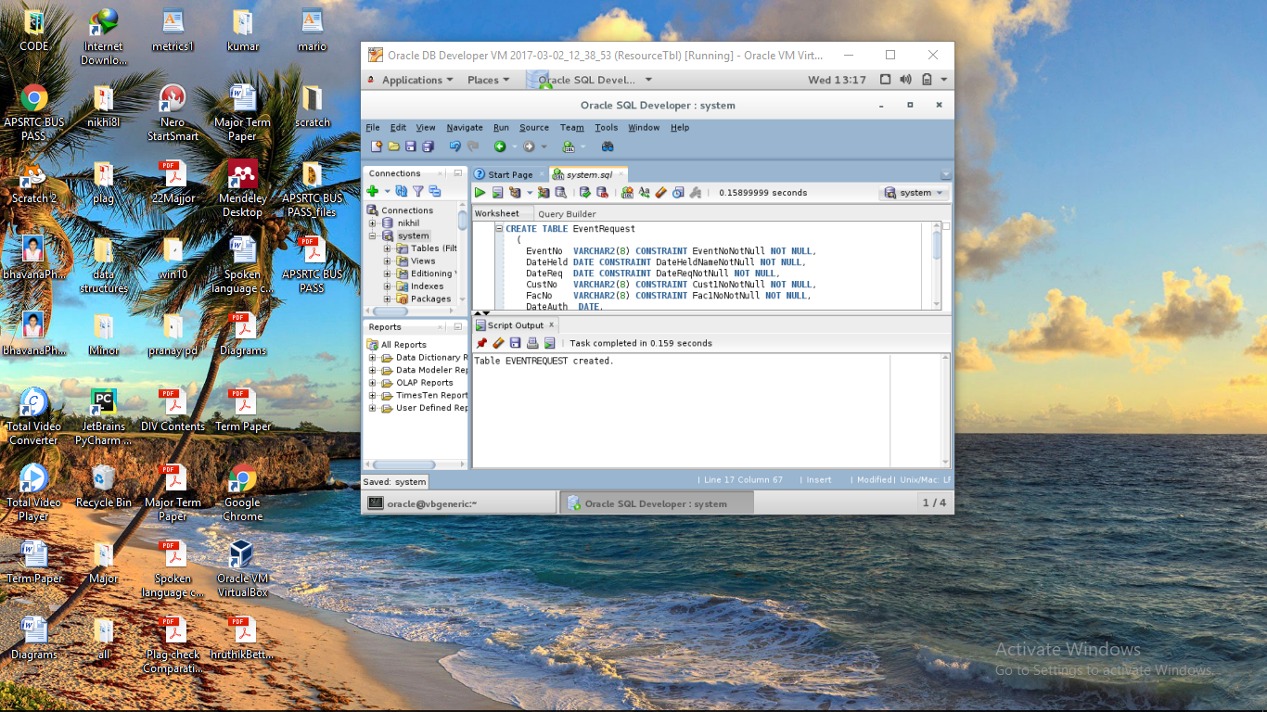

Select * from EventRequest;

